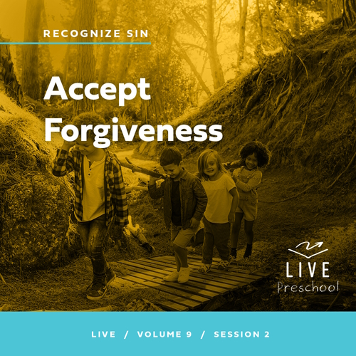

**Leader Overview**

**Volume Overview**

**Recognize Sin**

*The Bible has a lot to say about sin and forgiveness. It acknowledges the deep brokenness of this world and our individual life. It is only by understanding the depth of human sin that we can understand the remarkable work of God’s forgiveness. Because of His forgiveness, we escape the eternal consequence of our sin and can rightly respond to the call to live a holy life. We learn to receive forgiveness, put off sin, and show forgiveness to those who have sinned against us. We learn to pursue holiness in the midst of the world’s brokenness.*

**Session Overview**

**Accept Forgiveness**

*In this* **Live** *session, preschoolers will explore the forgiveness Jesus offers to everyone. As they look at Jesus’ forgiveness of the woman caught in sin, kids will learn that they can accept His forgiveness, too.*

**Bible Lesson**

A Woman Caught in Sin Receives Mercy

[John 8:1–11](https://ref.ly/logosref/Bible.Jn8.1-11)

**Faith Fact**

I can accept God’s forgiveness.

**Faith Verse**

[2 Corinthians 5:17](https://ref.ly/logosref/Bible.2Co5.17) (NLT)

Anyone who belongs to Christ has become a new person. The old life is gone; a new life has begun!

**Preparing for the Session**

**Leader Preparation Time: 20–25 Minutes**

|  |
| --- |
| ***You Will Need***  ***Preservice Activities***  *• Toys*  *•* ***Bible Story Warm-Up Page***  *• Prepackaged snacks (cookies, gummy bears, etc.)*  ***Large Group***  *• Bible*  *• Worship songs (Song suggestions: “Never Be Shaken” by Shout Praises Kids; “King of Me” by Rend Co. Kids; “Never Be the Same” by Fellowship Worship)*  *• For groups not using a phone or tablet only, add:*  *• Projector or TV*  *• Laptop*  *•* ***Faith Fact Sound*** *video (bell ringing)*  *•* ***Faith Fact Slide***  *•* ***Faith Verse Slide***  *•* ***Faith Verse Video***  *•* ***Bible Lesson Video A***  *•* ***Bible Lesson Video B***  ***Small Group***  *• Cookie sheet pan with rimmed edges*  *• Sand or brown sugar to cover cookie sheet pan*  *• Wooden skewer or plastic knife*  *• Medium-sized paintbrush, ½ inch or smaller*  *• Optional: Plastic tablecloth to protect floor from sand*  *•* ***Small Group Activity Page****, one per kid*  *• Crayons or markers*  *• Very large gift bag or open box wrapped as a present*  *• Tissue paper or wrapping paper*  *• Floor-safe tape*  *• Plate*  *• Penny*  *• Clear glass, large enough to cover the candle*  *• Red food coloring*  *• Lighter*  *• Candle*  *• Water*  *To access session content and videos from a computer, visit:* [***BibleEngagementProject.com/downloads***](https://bibleengagementproject.com/downloads) |
| ***Getting Ready***  ***Preservice Activities***  *• Set out toys and snacks.*  *• Print the* ***Bible Story Warm-Up Page****.*  ***Large Group***  *• Download videos and slides if needed.*  *• Select worship song(s) and have them ready to play.*  ***Small Group***  *• Fill the cookie sheet pan with sand.*  *• Use the skewer or knife to write this week’s Faith Fact,* ***I can accept God’s*** *forgiveness., in the sand.*  *• Optional: Place the tablecloth on the floor or table where activity will take place.*  *• Print copies of the* ***Small Group Activity Page****, one per kid.*  *• Wad up the paper into tight balls.*  *• Tape a throwing line in the playing area.*  *• Position the gift bag 8–10 feet from the taped line.*  *• Watch attached video link to show how experiment works:* [*https://www.youtube.com/watch?v=FjPvFddVVyE*](https://www.youtube.com/watch?v=FjPvFddVVyE)  *• Add red food coloring to the water*  *• Practice the object lesson to determine the correct amount of water to use.*  ***First time leading* Live *for Preschool? Check out the*** [**Facilitator Guide**](https://0b769b0ed3569ef9d18b-f88d8272f61086866d50d048b43ef630.ssl.cf2.rackcdn.com/sites/biblengagementproject/Listen_Facilitator_Guide.pdf)**.** |

**Preservice Activities**

*See what’s needed at the beginning of the session.*

**Bible Story Warm-Up**

Has anyone ever seen things like these before? *(Group response)*

• *Show the upper portion of the* ***Bible Story Warm-Up Page*** *to the kids.*

What kinds of things can you catch with them?

What are some other things you can catch?

What are some things you don’t want to catch?

Catching things can be a lot of fun, but some other things are not fun to catch like catching a cold. *(Show the third picture.)* It’s not very much fun to be sick. There’s one more thing we can catch. *(Show the fourth picture.)* That’s someone who is making a bad decision.

Have you ever caught someone doing something unsafe like in this picture?

Has someone ever caught you doing something you knew you shouldn’t do?

How did that make you feel?

Catching someone doing what they shouldn’t do is never fun. It can help them to be safe and choose to do the right thing. That’s why making the right choice is always the best thing to do. In the Bible Story today, we’ll learn about a time when someone was caught doing something wrong. We’ll see how Jesus and other people responded. This is a very important lesson, so be sure to keep your ears and heart open to what God wants to show you. I can’t wait to learn about this with you.

**Snack**

**Prepackaged Snacks (cookies, gummy bears, etc.)**

We have a fun snack today, and I want us to have some fun with it.

Do you like to play catch with a ball or stuffed animal? Let’s see if you can catch your snack today when I toss it to you. We’ll clap for every kid whether they catch their snack or not. Everyone gets a turn at catching a snack and then we’ll eat our snack at the same time.

• *Toss a prepackaged snack to each kid. When everyone has a snack, kids can open the snack and enjoy.*

**Free Play**

*Any extra time can be spent playing with toys.*

**Transition**

*A few minutes before service begins have kids make their way to the large group area and sit in their designated areas.*

**Large Group**

**25 Minutes**

*See what’s needed at the beginning of the session.*

**Introduction**

Hi, friends! I have a question for you. Can you look at my face *(smile big)* and figure out how I feel about being here with you today? *(Group response)* Yes, I’m so happy! We’ll have a great time exploring the Bible together. *(Hold up the Bible.)*

Today, we’ll learn about Jesus and the forgiveness He gives to everyone who asks Him for it. Raise your hand if you’ve ever done something wrong. *(Raise your hand.)* We have all made choices that are wrong. I know that because the Bible says we’ve all sinned. But Jesus came to earth to show us that He wants us to have forgiveness for every wrong thing we’ve done.

**Faith Fact**

God offers us that forgiveness, and all we have to do is accept it. That’s our Faith Fact today. **I can accept God’s forgiveness.**

• *Show the* ***Faith Fact Slide.***

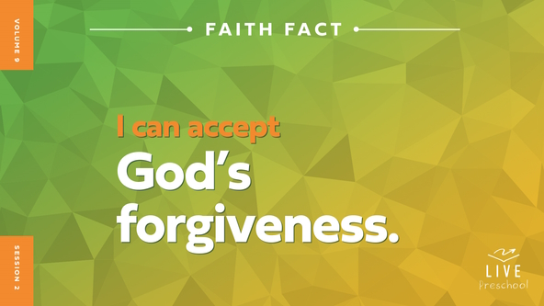

When we say our Faith Fact together, let’s point to ourself when we say the word *I* in our Faith Fact. Ready? **I can accept God’s forgiveness.** Let’s point up as we say the most important name in our Faith Fact, the name of God. **I can accept God’s forgiveness.** Awesome!

**Bible Time**

Let’s find out more about God’s forgiveness. One of my favorite things is exploring Bible stories in God’s Word with you. We have a special friend who helps us do that. Let’s see what Lizzy is doing.

• *Play* ***Bible Lesson Video A****.*

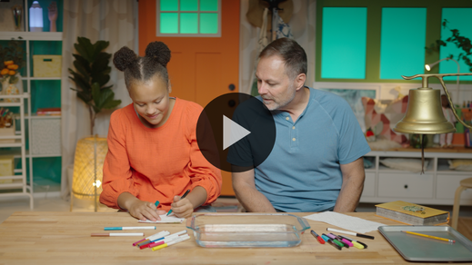

I’m glad Grandpa and Lizzy gave us a little time to think. Let’s worship, and then I’ll ask you what you think is going to happen next in our Bible story.

**Worship**

When I hear a Bible story, I’m always reminded of how God wants to be close with us. Even when we mess up or make mistakes, God wants to give us forgiveness and draw us close. Let’s give God our best praise and worship.

**Praise**

Are you glad God loves us so much? Stretch your arms as wide as they can go. *(Group response)*

Are you glad God wants to forgive you? Wrap your arms tightly around yourself. *(Group response)*

Who wants to say yes to God’s forgiveness? Wave your hands up high and say, “Yes.”

**Sing**

Let’s use our singing voices to tell God how great He is.

• *Lead the kids in singing one or two songs. See song suggestions at the beginning of the session.*

**Prayer**

Worshipping God is such a good reminder of God’s big, gigantic love for us. Let’s bow our heads and pray.

|  |
| --- |
| *Dear God, thank You for loving us. You see us exactly as we are, and You draw us close to You. We accept Your forgiveness, and we ask that You help us forgive people in our life that we need to forgive, too. Amen.* |

**Bible Time cont’d**

It’s almost time for Grandpa and Lizzy to come back. Let’s put on our thinking cap *(demonstrate)*. What do you think happened next in our Bible story? Did Jesus forgive the woman for the wrong thing she had done? *(Point to “white heart” graphic.)* Or did He yell at her and point out all her sins? *(Point to “heart with scribble” graphic.)*

• *Have kids do the following actions.*

If you think Jesus forgave the woman, show me a happy face *(demonstrate)*. If you think Jesus yelled at the woman, make your angry face *(demonstrate)*. Choose your answer.

• *Pause while kids respond.*

Let’s find out if you’re right! Time to check back in with Lizzy and Grandpa.

• *Play* ***Bible Lesson Video B.***

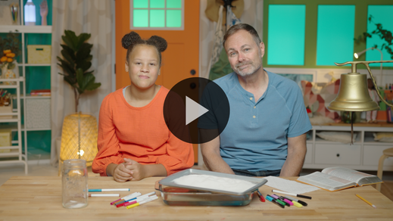

**Response Time**

*Play a worship song quietly.*

What a great story about God’s great love for us and how He wants to forgive us. Let’s respond to the truth we’ve heard from God’s Word. Can you put your hand on your heart while we pray this prayer?

• *Have the kids repeat phrases of the prayer after you.*

|  |
| --- |
| *Dear God, Thank You for the forgiveness You offer to me. I want to accept it. I want to be forgiven of my sin. I love You. Amen.* |

**Faith Verse**

God loves it when we learn Bible verses. Let’s practice our Faith Verse and do the actions together.

[2 Corinthians 5:17](https://ref.ly/logosref/Bible.2Co5.17) (NLT)

Anyone who belongs to Christ has become a new person. The old life is gone; a new life has begun!

• *Show the* ***Faith Verse Video.***

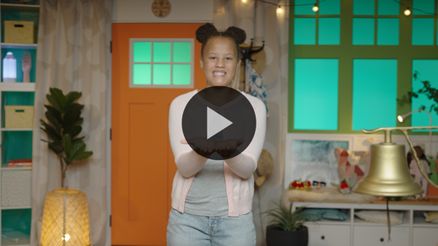

**2 Corinthians** *(hands at waist, spread apart, palms up and out)*

**5:** *(hands together like a clap)*

**17** *(hands opened to “book”)*

**Anyone who** *(point to other people)*

**belongs to Christ** *(do sign language for Jesus, middle finger to opposite palm, with each hand)*

**has become a new person.** *(spin around)*

**The old life is gone;** *(crouch low to ground)*

**a new life has begun!** *(jump with arms and feet spread wide)*

**Closing**

Did you enjoy learning about God’s forgiveness in our Bible story? *(Group response)* Me too! I also loved singing praise songs and practicing our Faith Verse together. This week, let’s remember that we can accept God’s forgiveness no matter what.

• *Play the* ***Faith Fact Sound*** *video (bell ringing).*

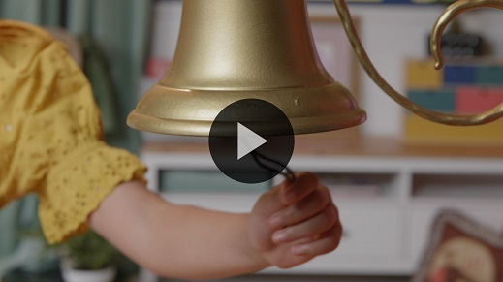

Hey! We have time to practice our Faith Fact one more time. **I can accept God’s forgiveness**.

• *Show the* ***Faith Fact Slide.***



Let’s say our Faith Fact in our smallest, squeakiest voices. **I can accept God’s forgiveness**. Now, let’s use our biggest voices to shout this important message. **I can accept God’s forgiveness.**

**Dismissal to Small Groups**

Your big voices are so strong! I have some exciting news for you. It’s time to go with your small groups to do some really awesome activities.

• *Dismiss the kids by groups.*

|  |
| --- |
| ***Leader Tip****: This can be done by assigning color teams or by age groups. Note that some young preschoolers may not know their age. Using a colored sticker, jersey, or wristband will help separate the kids and help identify their small groups.* |

**Small Group**

**25 Minutes**

*See supplies and prep instructions at beginning of session or in each activity below.*

|  |
| --- |
| ***Leader Tip:*** *Small groups can alternate to each circle, or all groups can do each activity at the same time. If you choose to alternate, you will need at least one leader per circle.* |

**Circle 1**

**Group Connection**

**Sin No More**

|  |
| --- |
| ***You Will Need***  *• Cookie sheet pan with rimmed edges*  *• Sand or brown sugar to cover cookie sheet pan*  *• Wooden skewer or plastic knife*  *• Medium-sized paintbrush, ½ inch or smaller*  *• Optional: Plastic tablecloth to protect floor from sand*  ***Getting Ready***  *• Fill the cookie sheet pan with sand.*  *• Use the skewer or knife to write this week’s Faith Fact,* ***I can accept God’s forgiveness****., in the sand.*  *• Optional: Place the tablecloth on the floor or table where activity will take place.* |

During our Bible story, we learned that Jesus wrote something in the sand. Now, the Bible doesn‘t tell us what He wrote. What He wrote wasn’t the most important part of the story. What’s most important is what happened after that. After Jesus wrote in the sand, He talked to the woman. He forgave her and told her not to sin anymore.

• *Set out the pan of sand.*

For this activity, we’ll each say one word of our Faith Fact as we go around the circle and pass this paintbrush *(hold up paintbrush)* to the person next to us. Whoever says *forgiveness* will take the paintbrush and erase one letter from the sand. Let’s do it!

• *Lead kids through saying the Faith Fact and passing the paintbrush.*

You all did such a great job at erasing those letters, but an even better job at saying the Faith Fact! This Faith Fact is something I want you to remember for the rest of your life. Great job, everyone!

**Circle 2**

**Activity Page Time**

**Bible Story Art**

|  |
| --- |
| ***You Will Need***  *•* ***Small Group Activity Page****, one per kid*  *• Crayons or markers*  ***Getting Ready***  *• Print copies of the* ***Small Group Activity Page****, one per kid.* |

In our Bible story, we saw Jesus stop a group of people who wanted to punish a woman who had been caught in sin. Jesus reminded everyone there that we all need God‘s forgiveness. The amazing thing is that when we accept God’s forgiveness and choose to follow Jesus, He takes our old life and makes us new. Let’s color the picture as a reminder of God’s forgiveness.

• *Hand out a copy of the* ***Small Group Activity Page*** *and crayons to each kid.*

• *During the activity, interrupt and practice the Faith Fact:* **I can accept God’s forgiveness.**

• *Play the* ***Faith Fact Sound*** *video. Review the Faith Fact even if you can’t play the sound.*



**Circle 3**

**Feet-to-Floor Game Time**

**Forgiveness Frenzy**

|  |
| --- |
| ***You Will Need***  *• Very large gift bag or open box wrapped as a present*  *• Tissue paper or wrapping paper*  *• Floor-safe tape*  ***Getting Ready***  *• Wad up the paper into tight balls.*  *• Tape a throwing line in the playing area.*  *• Position the gift bag 8–10 feet from the taped line.* |

If you’re ready to play a game, let me hear you say, “Oh, yeah!” *(Group response)* Before we play, I have a question for you. Can anyone tell me what our Faith Fact is today? *(Allow responses.)* That’s right, our Faith Fact is **I can accept God’s forgiveness**. One of the best things about God’s forgiveness is that He chooses to give it to us when we ask. You don’t have to work for it. You don’t have to chase God down and try to catch Him. It’s something that He wants to give to you. This game will help us remember that God gives His love and forgiveness to us. It’s His gift to us.

For each round, we’ll have two catchers while the rest of team takes turns throwing these paper balls *(hold up paper wads)* to them. If you’re a catcher, your job is to catch the papers and place them in the gift bag. Every time a paper goes into the bag, everyone on the team says the Faith Fact together. If you’re ready, say, “Let’s go!” *(Group response)*

• *Play as many rounds as time allows, giving each kid an opportunity to be the catcher if they want to.*

That was so much fun! I loved watching you work together. I hope that you will always remember that God’s forgiveness is a gift and that you can accept it!

**Circle 4**

**Hands-On Learning**

**Sin Away Object Lesson**

|  |
| --- |
| ***You Will Need***  *• Plate*  *• Penny*  *• Water*  *• Red food coloring*  *• Candle*  *• Clear glass, large enough to cover candle*  *• Lighter*  ***Getting Ready***  *• Watch video link to see how experiment works:* [*https://www.youtube.com/watch?v=FjPvFddVVyE*](https://www.youtube.com/watch?v=FjPvFddVVyE)  *• Add red food coloring to the water.*  *• Practice the object lesson to confirm the correct amount of water to use.* |

Today has been amazing! We’ve learned that God wants to forgive our sins so that we can be with Him forever. In our Bible story today, we heard about a woman who got caught doing something wrong. Jesus looked at her, forgave her, and told her to go and sin no more. Part of accepting God’s forgiveness is choosing to turn away from sin and not to keep doing wrong.

Sometimes our sin may feel too big for God to forgive. Sometimes we might feel like we need to do something to earn His forgiveness. The good news for us is that He sent Jesus to save us from our sin. When He forgives us, He doesn’t just take some of our sin away. He takes it all.

We are like this penny *(place it on the plate)* and this red water is our sin. When we sin, it covers our life *(pour water on the plate)* and leaves us separated from God. When Jesus comes into our life, He brings forgiveness and light *(light candle and place it on plate).* He will take away our sin *(place glass over candle)* if we ask Him to.

Look! The sin is gone, and our penny is no longer covered in the water. This is what happens when we accept God’s forgiveness. The sin is no longer covering us. Isn’t that great? *(Group response)* God wants us to remember that He loves us and offers forgiveness when we ask.

**Dismissal**

• *Play the* ***Faith Fact Sound*** *video (bell ringing).*



• *Show the* ***Faith Fact Slide.***



Today has been absolutely awesome! I’ve learned so much with you. I think my favorite thing we’ve learned is that God wants to forgive us. Wait! That reminds me of our Faith Fact. Before we go, can we say it together again? *(Group response)* **I can accept God’s forgiveness.** Great job! I had a great time learning more about God’s Word with you. See you next time!

• *Send home the* ***Small Group******Activity Page*** *with each kid.*

• *Remind parents that there are* ***Family Devotions*** *available on the app to do with their kid.*

• *Tell everyone the date and time for the next session.*